NMR
Nuclear Magnetic Resonance (NMR) spectroscopy is one of the principal techniques used to obtain physical, chemical, electronic and structural information about molecules. It is a powerful technique that can provide atomic resolution information on the topology, dynamics and three-dimensional structure of molecules in solution and the solid state. The breadth and quality of information attainable from NMR measurements makes it unique among spectroscopic tools.
Example applications include:
- Structure determination; either at atomic resolution for highly-ordered macromolecules, or through defining structural propensities of more dynamic molecules such as unfolded proteins or carbohydrates.
- NMR can provide in-depth characterisation of intermolecular interactions, making it a powerful tool in drug discovery.
- Dynamics measurements on large molecules (macromolecules), to determine how such processes control biological function, for example in the folding of proteins, intermolecular signalling and biological catalysis.
Introduction of specific labels allows the probing of particular regions of interest in proteins, for example using fluorine compounds to probe the environment in active sites of enzymes, or the dynamics of peptides in complex with larger proteins, which have been perdeuterated to render them NMR silent.

Enquiries
Dr Matthew Cliff | matthew.cliff@manchester.ac.uk | Tel: +44 (0)161 306 5179

Biophysics
The MIB Biophysics Facility contains state-of-the-art facilities in advanced spectroscopy and kinetic techniques. We offer a range of biophysical techniques with many applications:
- Enzyme assays: from development through to high-throughput capabilities
- Rates of individual steps in catalysis
- Understanding reaction mechanisms
- Identifying new reaction intermediates
- Optimising reaction conditions
- Inhibitor studies
- Ligand binding assays
- Protein-protein interactions
- Anaerobic reactions
- Identifying rate-limiting steps in a reaction
- Redox chemistry
- Plus many more

Enquiries
Dr Derren Heyes | derren.heyes@manchester.ac.uk | Tel: +44(0)161 306 5159

Mass Spectrometry
MS is used for determining masses of particles, for determining the elemental composition of a sample or molecule, and for elucidating the chemical structures of molecules. It works by ionizing chemical compounds to generate charged molecules or molecule fragments and measuring their mass-to-charge ratios. The MIB hosts a wealth of capability in mass spectrometry.

Enquiries
Reynard Spiess | reynard.spiess@manchester.ac.uk | Tel: +44(0)161 306 5157

Michael Barber Centre for Mass Spectrometry
Gas-phase ion chemistry research provides an enhanced understanding of the analytical techniques that underpin proteomics, metabolomics and the investigation of other molecules of biological significance. New developments in quantitative mass spectrometry provide much needed information for modeling of biological networks, while techniques are being developed for the analysis and quantification of a variety of post-translational modifications.

MassSpec@Manchester
Mass spectrometric research has a long and rich history at The University of Manchester. In this network we attempt to bring together the experience and expertise of these researchers under one umbrella.

Services
- Fast, simple and accurate sample confirmation
- Sample Accurate Mass determination
- Whole protein mass determination
- LC-MS fragment and component analysis
- Small molecule identification
- Confirm and analyze purity of sample mixtures
- Unknown sample identification
- Training and support for new users

Secondary Ion Mass Spectrometry (SIMS)
SIMS is developed and used for the analysis and imaging of chemical and biological systems, including advanced materials, single cells and biological tissue. The aims involve novel insights into the chemical and spacial organisation and function of these systems at the molecular level.
Nick Lockyer and John Vickerman are developing applications of SIMS in areas involving the characterisation and classification of cells and tissue at the molecular level. They are also working closely with industry to develop new instrumentation and analytical protocols to advance SIMS applications in biosciences.

Enquiries (SIMS)
Dr Nick Lockyer | nick.lockyer@manchester.ac.uk | Tel: +44(0)161 306 4479

Related links
- Michael Barber Centre for Mass Spectrometry
- MassSpec@Manchester

Protein expression
We provide a comprehensive resource for the high level expression and scale-up production of recombinant proteins. Currently we offer a choice of four expression systems: bacteria, pichia, insect and mammalian cells. Depending on particular needs we are able to provide either small scale production facilities for biochemical analysis and antibody production or larger scale production for structural studies. We can offer:
- High level expression and scale-up production of recombinant proteins
- Protein purification (Native or His/GST/MBP tagged proteins. Second stage polishing can be carried out using ion exchange or gel filtration chromatography). Tag removal using thrombin or other selective proteases (eg TEV/ Precission)
- Cloning service
- Troubleshooting & advice service
- In-house R&D vector design
- Training courses

Enquiries
Dr Eddie McKenzie | edward.a.mckenzie@manchester.ac.uk | Tel: +44 (0)61 306 4170

Protein structure
X-Ray crystallography utilises X-ray diffraction by single protein crystals to elucidate three dimensional structures at atomic resolution. The technique plays a pivotal role in understanding how individual amino acids interact with small molecule ligands and cofactors.
The MPSF (Manchester Protein Structure Facility) provides a complete service pipeline, taking you from purified protein to crystal structure. The MPSF is serviced by two full time senior experimental officers. Expert users can gain access to the facility equipment, whilst non experts are offered a complete service pipeline for structure elucidation.
Meeting the often rate limiting challenge of crystallogenesis are two complementary high throughput nanolitre dispensing robots (Mosquito & Phoenix) allowing rapid screening and optimisation. The facility also houses two rotating anode X-ray generators and associated data collection equipment. These in-house facilities are further supplemented with regular synchrotron access.
All services and equipment are available to both University of Manchester researchers and external users (academic & commercial).

Enquiries
Dr Colin Levy ¦ c.levy@manchester.ac.uk ¦ Tel: +44 (0)161 275 5090

SYNBIOCHEM Facilities
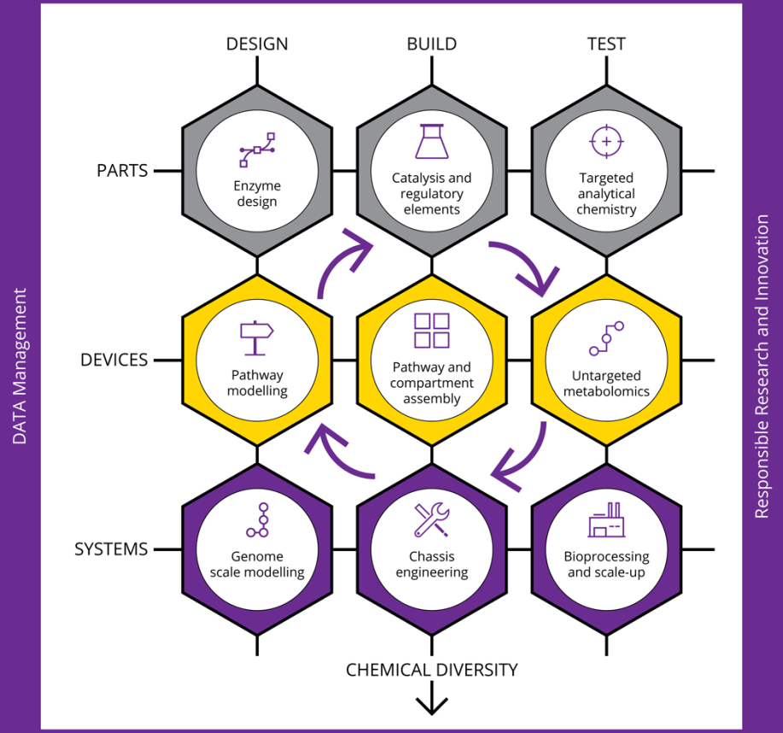
The Centre has developed a series of unique and highly integrated interdisciplinary technology platforms and a truly world-leading physical infrastructure for contemporary fine and speciality chemicals production supported by a dedicated team of expert Experimental Officers. Projects run across the technology platforms integrating the Design/Build/Test/Learn cycles. Following on from our initial set-up and verification phase, access to the equipment and resources of the Centre is available through the experimental officers and collaborative projects will be welcome.
Please contact Ros in the first instance – for technical enquiries feel free to contact the EO team (See SYNBIOCHEM People).

General Enquiries: Dr Rosalind Le Feuvre – Director of Operations
T: +44 (0)161 306 5184
E: r.a.le-feuvre@manchester.ac.uk
http://synbiochem.co.uk/people/
SYNBIOCHEM Synthetic Biology Research Centre, Manchester – A UK foundry for fine and speciality chemicals production. Le Feuvre RA, Carbonell P, Currin A, Dunstan M, Fellows D, Jervis AJ, Rattray NJW, Robinson CJ, Swainston N, Vinaixa M, Williams A, Yan C, Barran P, Breitling R, Chen GG, Faulon JL, Goble C, Goodacre R, Kell DB, Micklefield J, Scrutton NS, Shapira P, Takano E, Turner NJ. (2016). Synthetic and Systems Biotechnology, 1: 271-5.

